Student’s Name: Kibet Brian
Admission Number: 190814
Lecturer’s Name: Dr. Vitalis Ozianyi
Course Unit: MST 8304 Cloud Computing Security, CCS
Course Code: MST 8304
Lab 2 - Nagios Manager and NRPE Server Setup - Controller Mode
Date: August 3rd, 2025

Lab 2 - Nagios Manager and NRPE Server Setup - Controller Mode
The 4 Debian VMs.
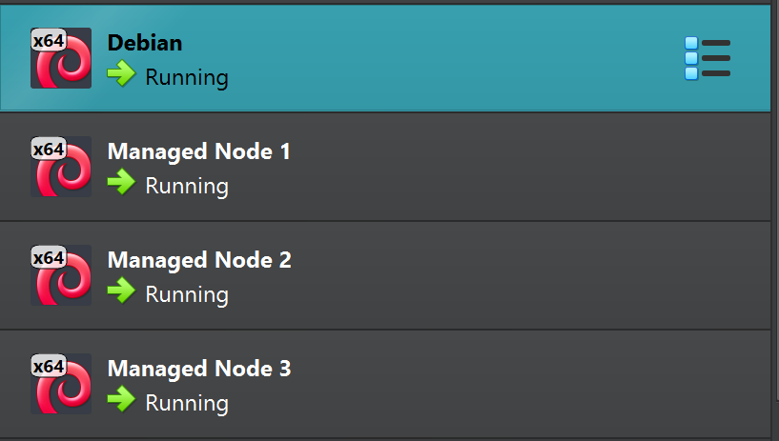

Managed Node 2 IP Address:
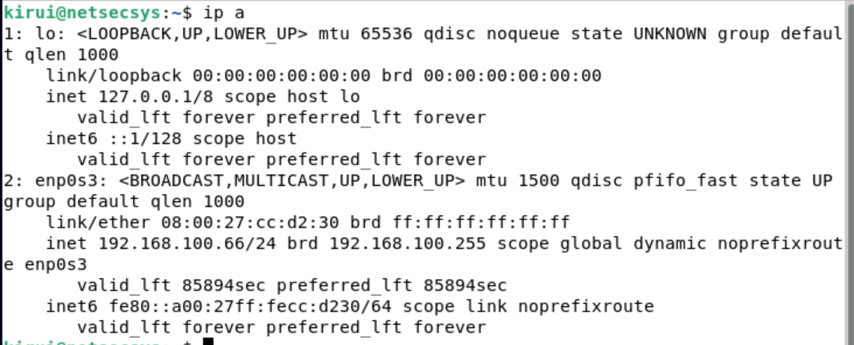

Managed Node 3 IP Address.
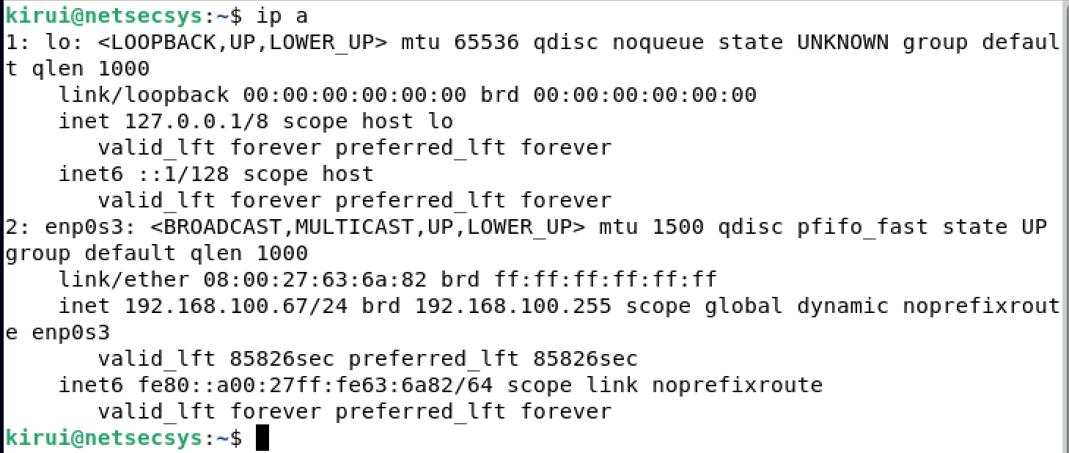
Using winscp to copy networkAutomation to the controller.
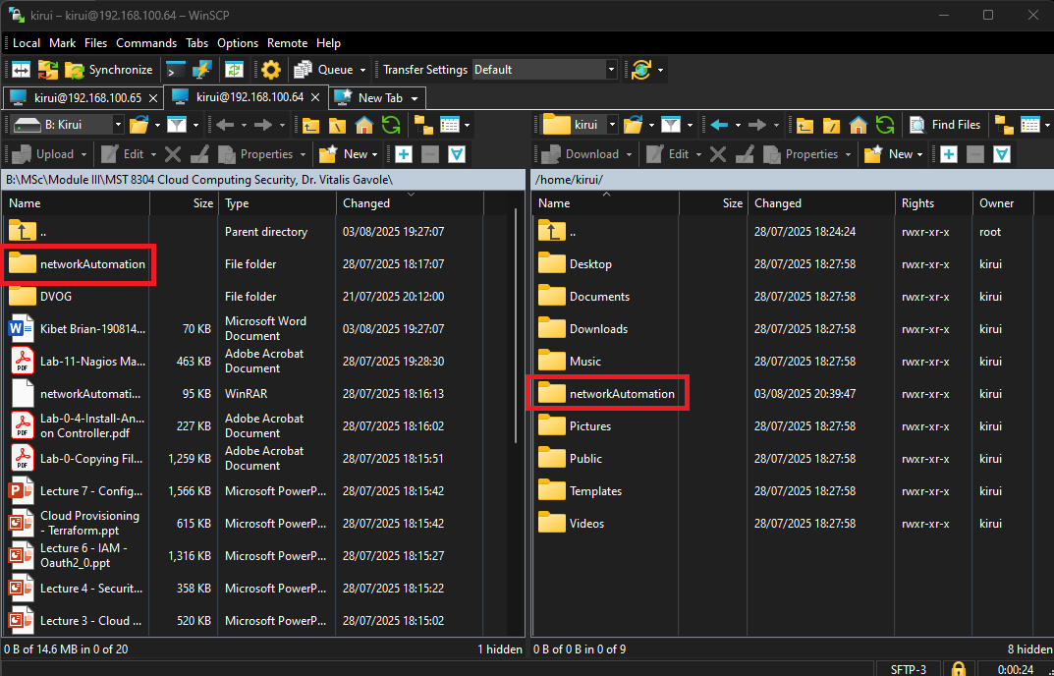

Debian Controller IP Address:
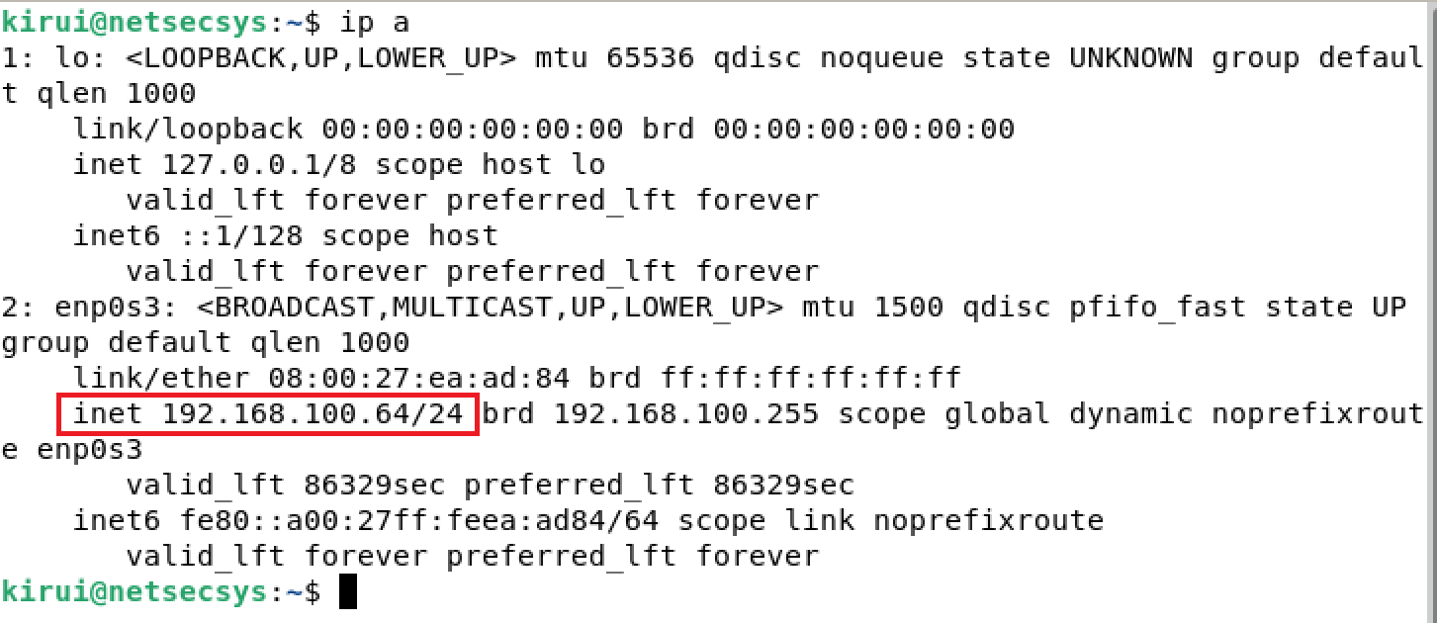

Switching to root user, and verifying the networkAutomation folder was copied.
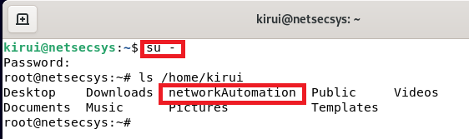

Generating SSH Key Pair.
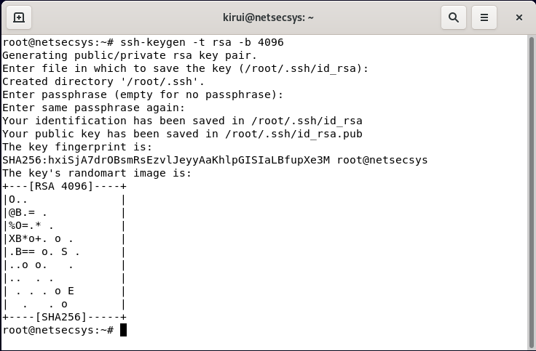

Copying SSH Public Key to Managed Nodes

Already setup on Managed Node 1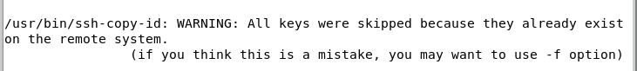

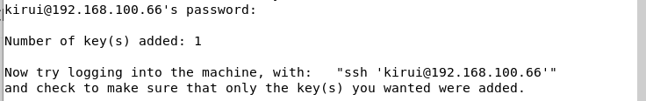

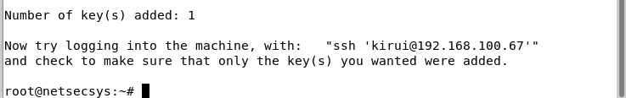
Installing ansible.
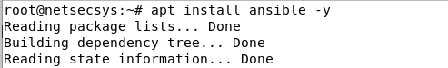

Checking it’s version.
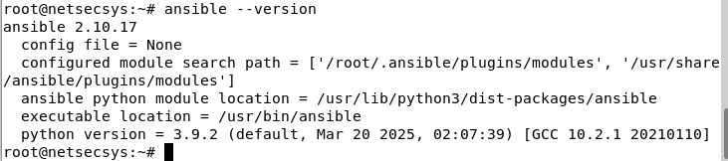

Confirming configuration folder
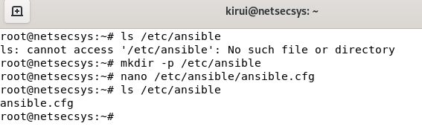

Testing ansible connectivity to all managed nodes.
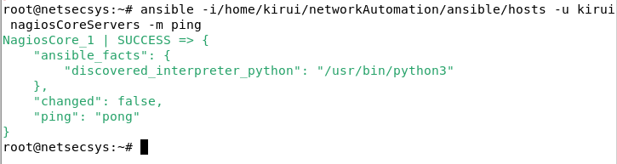

Running the Playbook to configure bind DNS on the managed nodes.
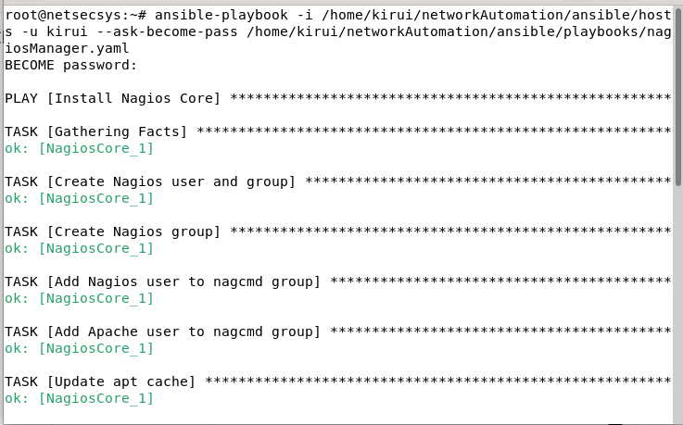
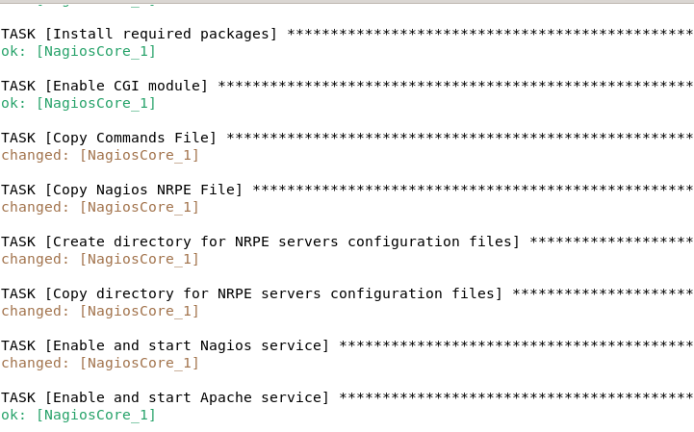
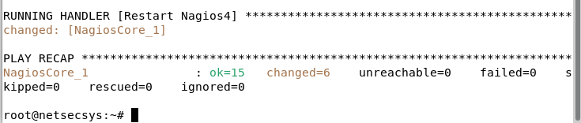
Hosts
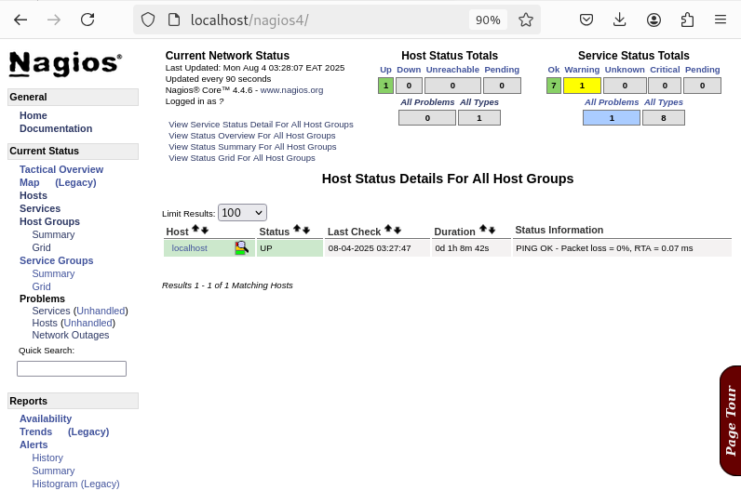
Services
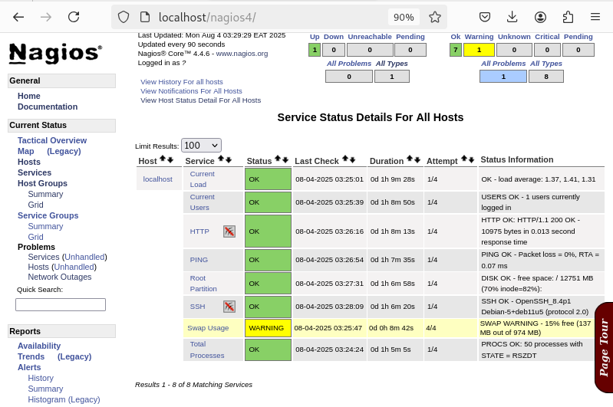

Playbook preparation
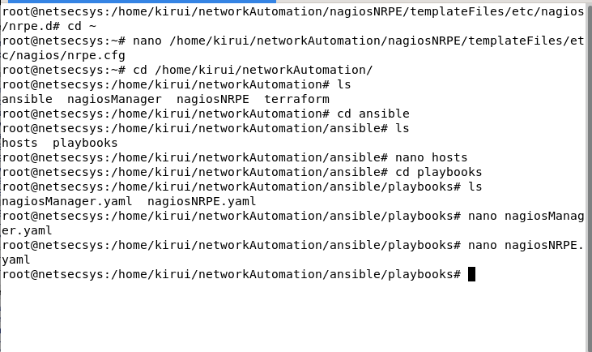

Cleaning up bash script
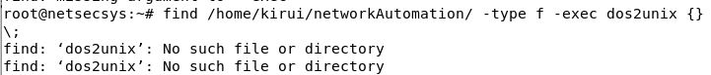

Testing ansible connectivity to all managed nodes
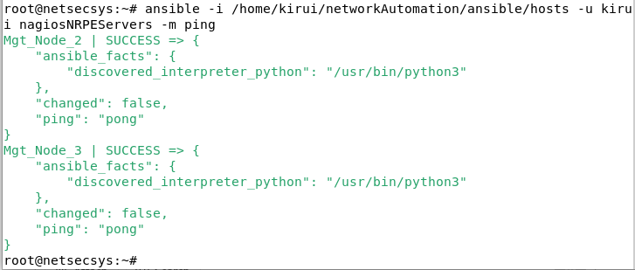

Running the playbook to configure bind DNS on the managed nodes.
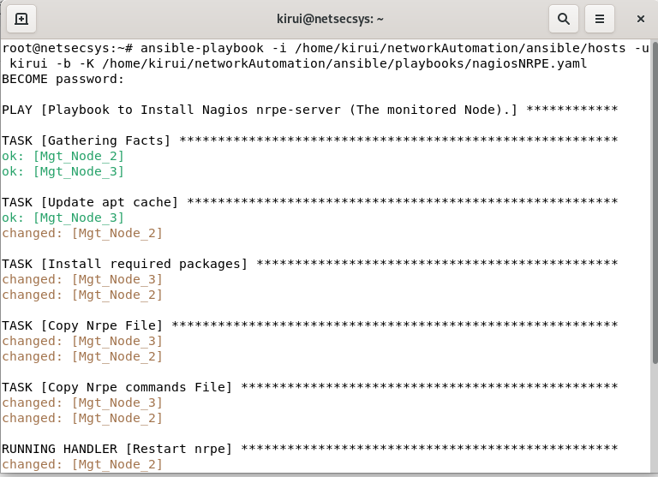
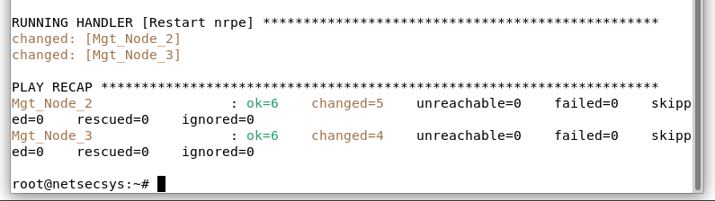

Verifying nagios manager server configuration
Hosts tab.
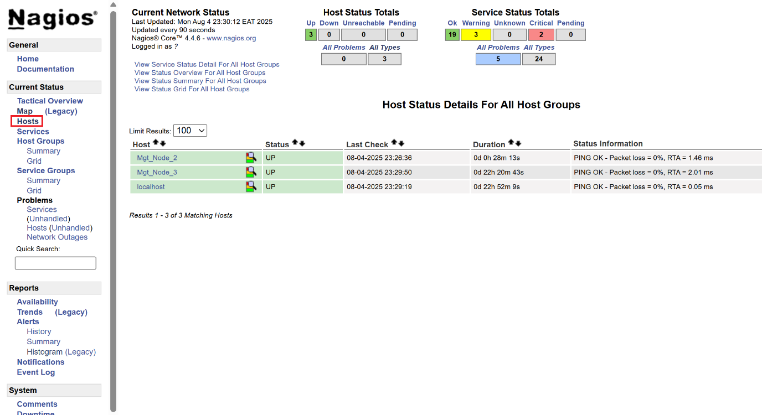

Services tab
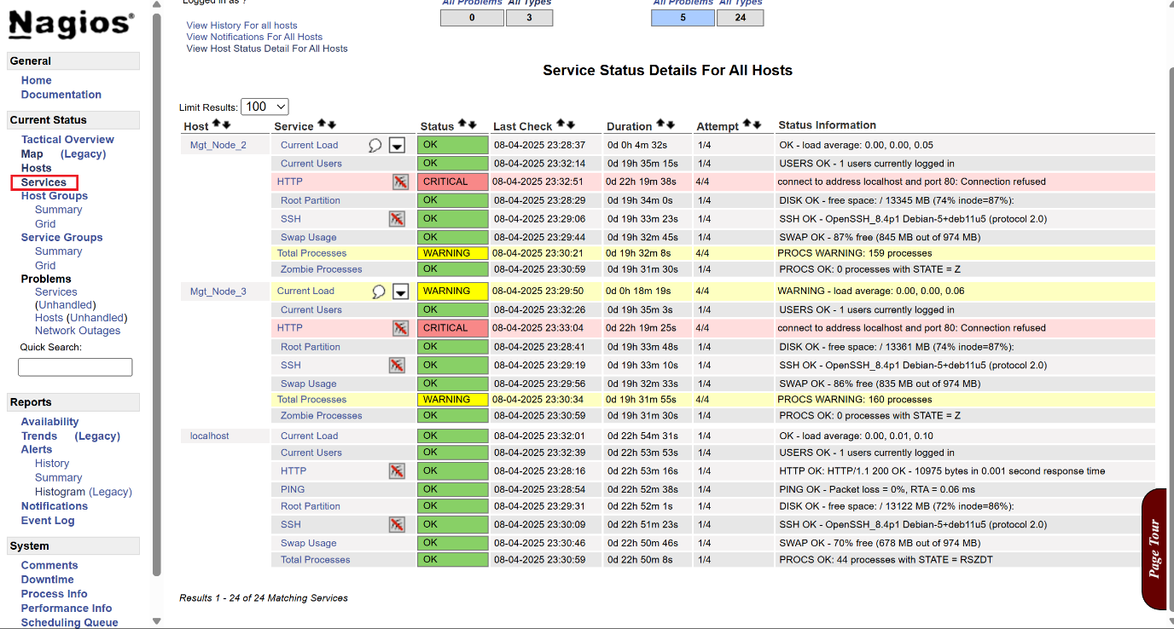
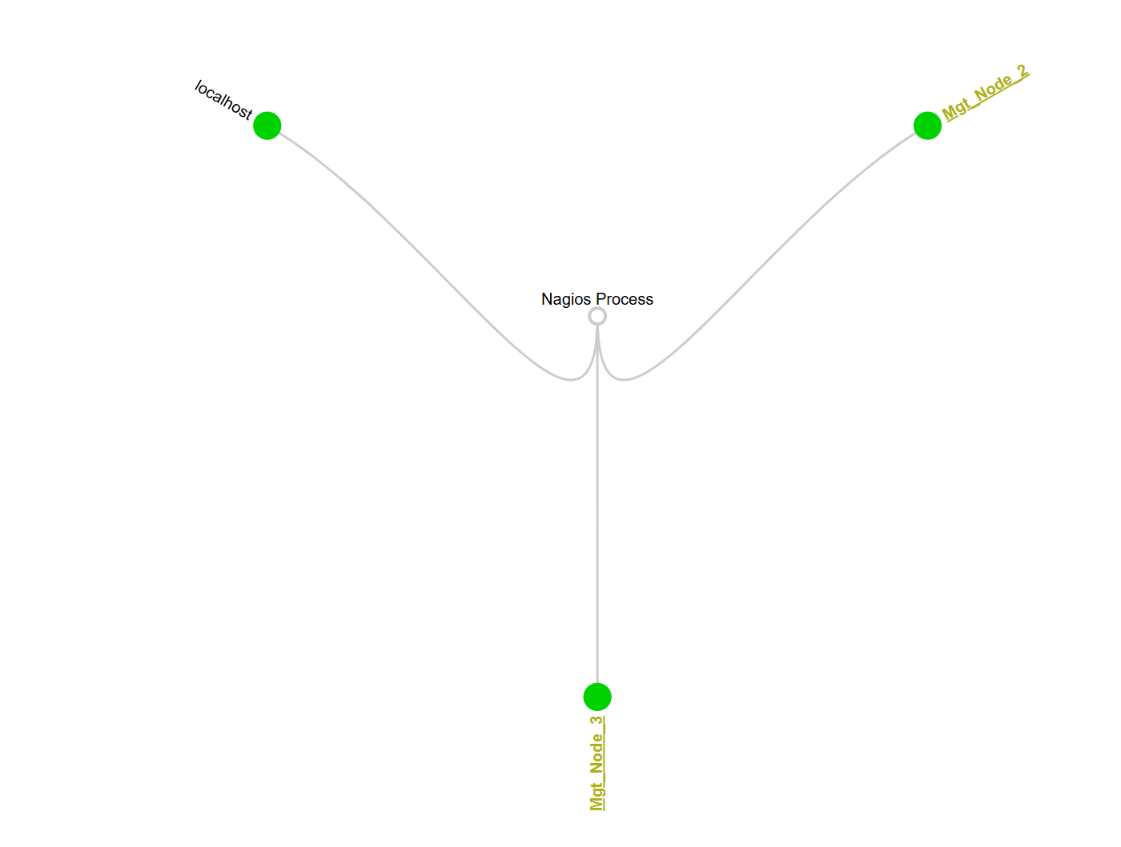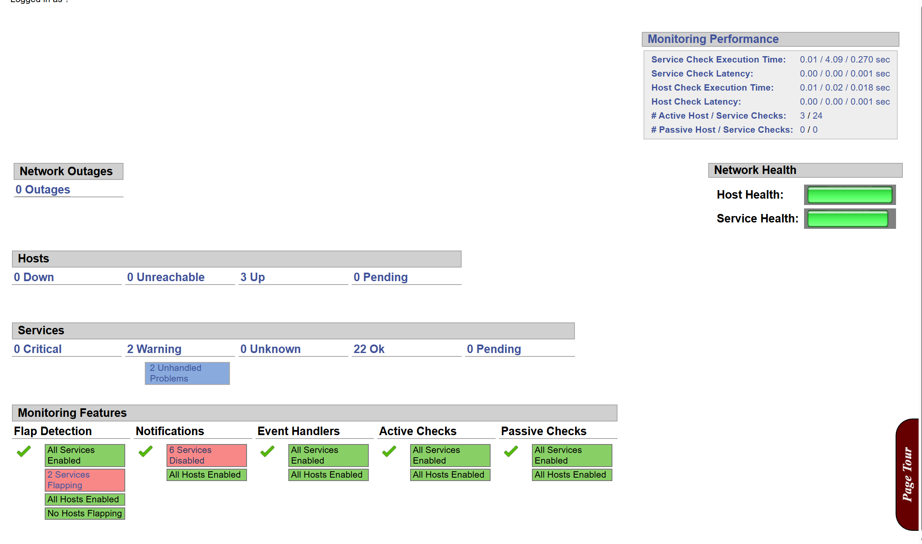

All services are now running OK.
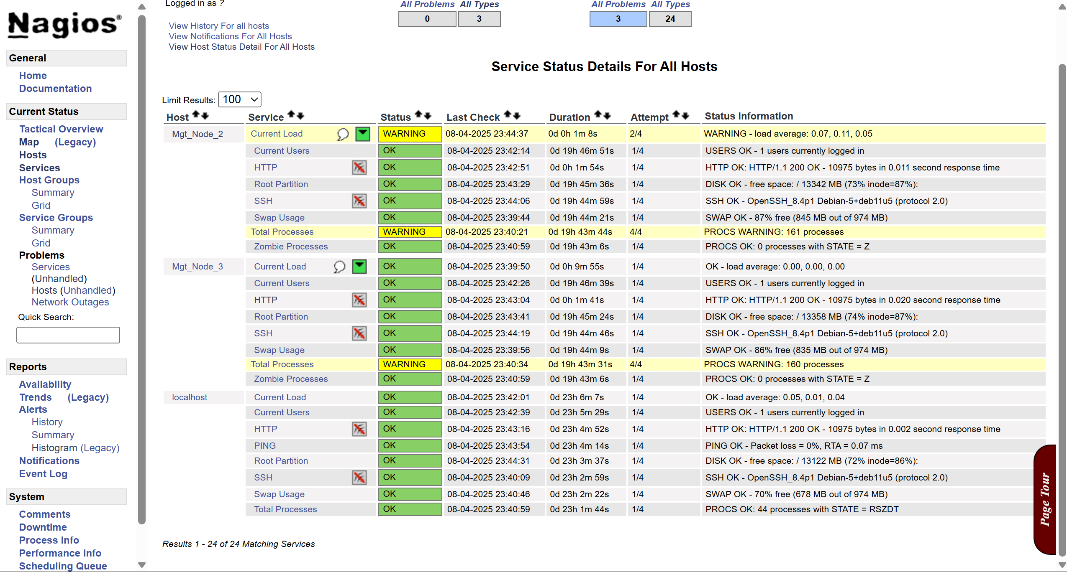

Based on the services screenshot, my observation is that “All services are running OK.” This means Nagios Manager successfully communicated with the NRPE servers, and the monitoring checks are returning healthy results. The automated setup and configuration via the playbook worked correctly, enabling proper monitoring of the managed nodes. The system is functioning as intended, with all services operational and reporting accurate status.

